self.base_task_reward = 30.0 # Increased base reward

self.energy_efficiency_multiplier = 0.5

self.budget_utilization_factor = 0.8

self.battery_conservation_bonus = 1.5

self.consecutive_success_factor = 2.0

# Penalty multipliers

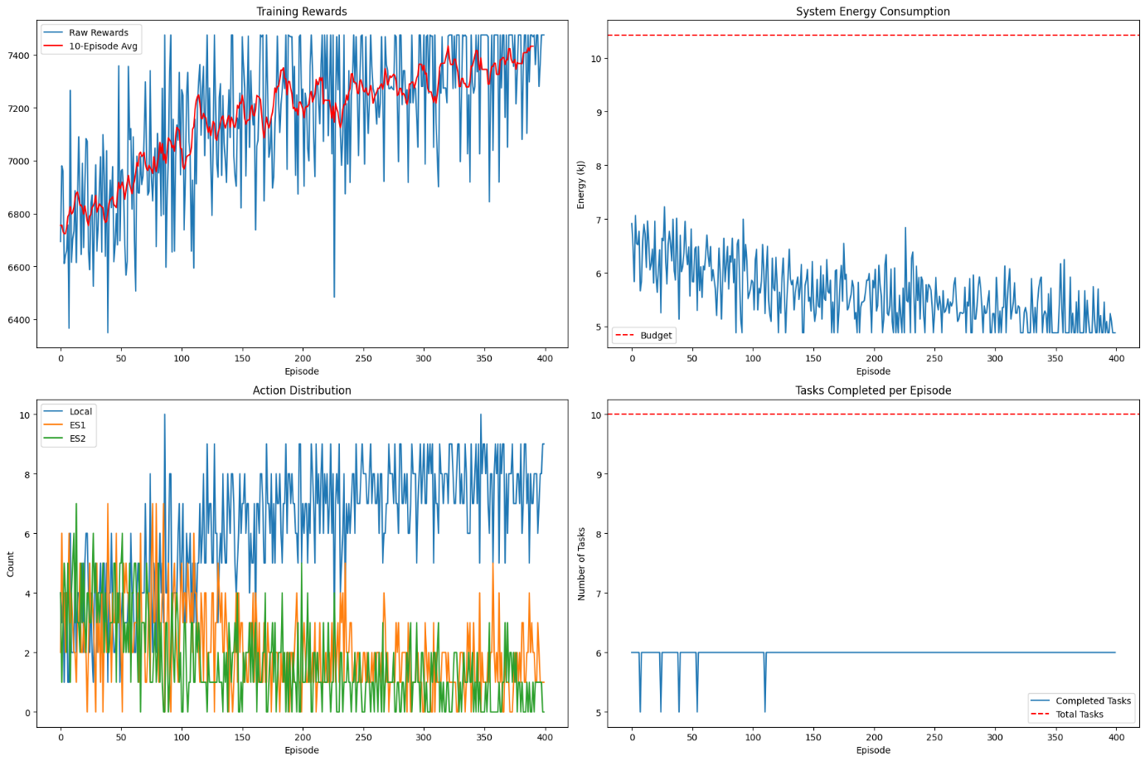self.budget_violation_exponent = 1.0

self.base_task_reward = 20.0

self.energy_efficiency_multiplier = 2.0 # Strong emphasis

self.budget_utilization_factor = 1.5

self.battery_conservation_bonus = 3.0

self.consecutive_success_factor = 1.2

# Energy-specific parameters

self.optimal_energy_threshold = 0.85 # Tighter threshold

self.energy_use_history_weight = 0.3 # New parameter

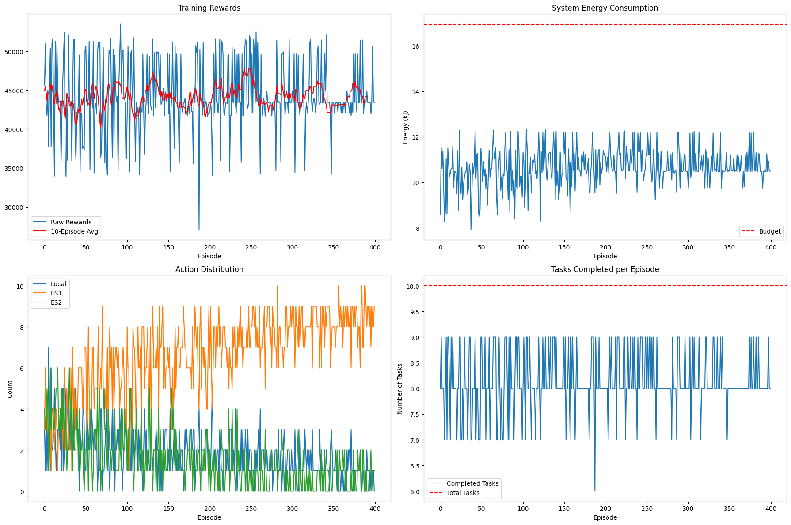

self.base_task_reward = 25.0

self.energy_efficiency_multiplier = 1.0

self.budget_utilization_factor = 1.2

self.battery_conservation_bonus = 2.0

self.consecutive_success_factor = 1.5

# Non-linear rewards

self.progressive_task_bonus = 0.1 # Per consecutive success

self.degressive_penalty = 0.95 # Penalty decay factor

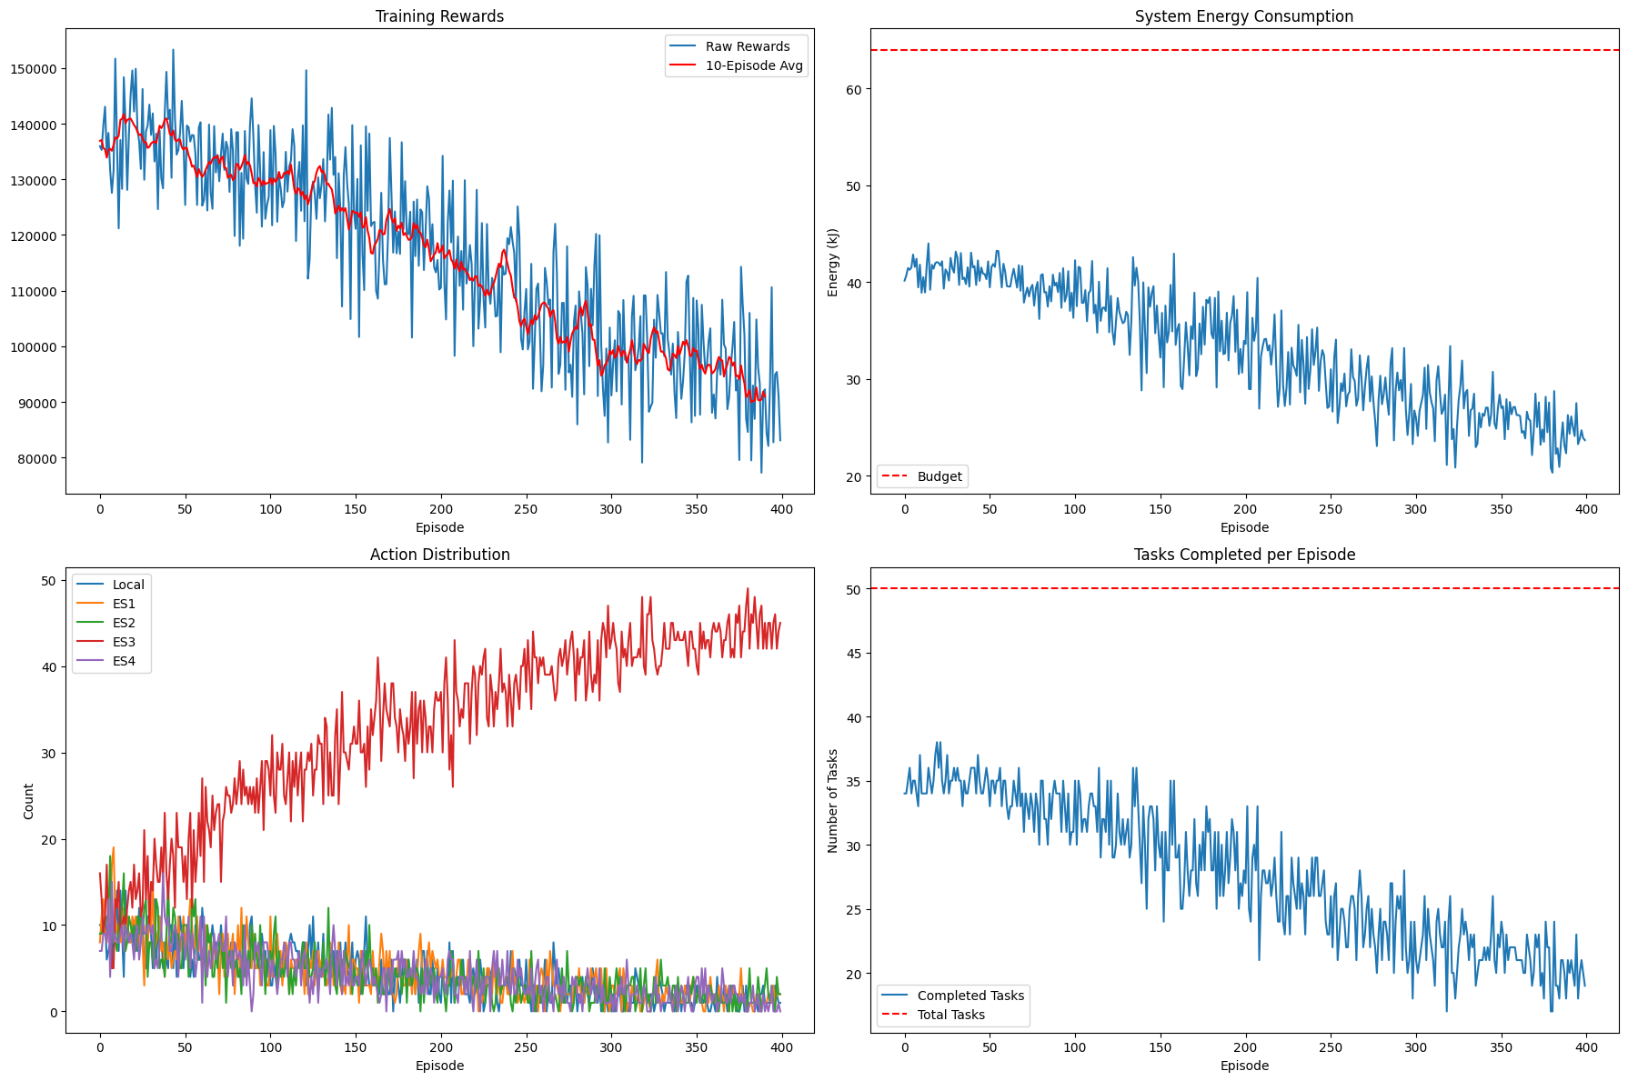

**Stress Testing in old model**

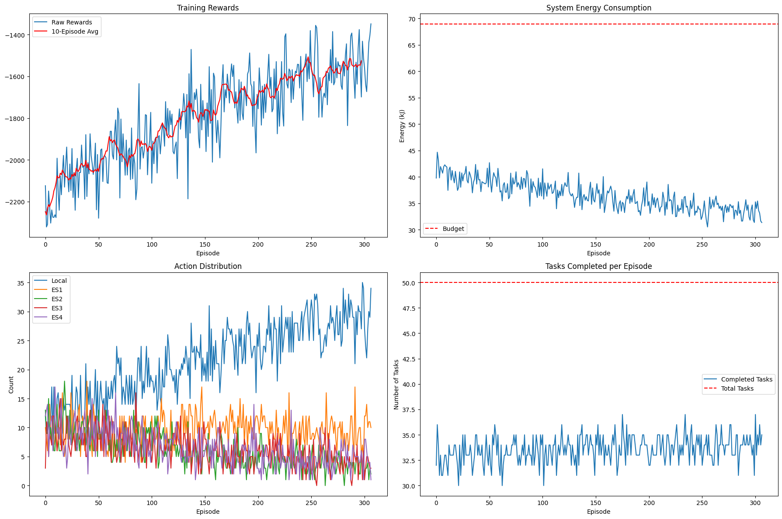

**Task Completion Graph under stress**



